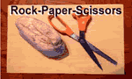
C/C++ ROCK PAPER SCISSORS LAB REPORT

1) Enter your name, student ID, platform (Mac or PC) and date
Name and Student ID: Jay Gupta, Student ID: 0961979
Class: CIS054 C/C++ Programming
Platform (Mac or PC): PC
Development System (Visual Studio, Xcode, etc.): Visual Studio Code
Date: 2/14/2020

OBJECTIVES:
Input player inputs using cout/cin (for C++) or printf/scanf (for C)
Use nested if/else if/else statements to determine the outcome of the game
Identify illegal inputs from the user and display an error message
Use a while loop to repeat the game

DESCRIPTION: Chapter 3 Programming Project #1 (page 170 8th Edition, page 172 9th Edition)
Write a program to score the rock-paper-scissor game. Each of two users types in either R, P, or S. The program then announces the winner as well as the basis for determining the winner: Paper covers rock, Rock breaks scissors, Scissors cut paper, or Nobody wins. Be sure to allow the user to use lowercase as well as uppercase letters. Your program should include a loop that lets the user play again until the user says she or he is done.

2) Determine the Inputs, Processing and Outputs before creating the program
INPUTS | PROCESSING | OUTPUTS
Player1 and Player2 as  (R)ock, (P)aper, or (S)cissors.  Additionally,  Does the player want to play again? (Y or N) | If player1 and player2 are the same, it is a tie. If a player has rock, and the other has scissors, the former wins. If the other has paper, the latter wins. If the first player has scissors, and the other has rock, the latter wins, and if the latter has paper, the former wins. Finally, if the first player has paper, and the other has scissors, the latter wins, and if the other has rock, the former wins. | The winner of the round (either Player1 or Player2), or if it was a tie.

3) Fill in the EXPECTED & ACTUAL RESULTS
TEST DATA VALUES | EXPECTED RESULT  Computed values before the program is run |  | ACTUAL RESULT  Fill in the output displayed  by the program
 | - Tie game, nobody wins.  - Player 2 wins, paper beats rock.  - Player 1 wins, rock beats scissors.  - Player 1 wins, paper beats rock.  - Tie game, nobody wins.  - Player 2 wins, scissors beats paper.  - Player 2 wins, rock beats scissors.  - Player 1 wins, scissors beats paper.  - Tie game, nobody wins.  - Illegal Selection, Player 1. Try again.  - Illegal selection, Player 2. Try again. | - Tie game, nobody wins.  - Player 2 wins, paper beats rock.  - Player 1 wins, rock beats scissors.  - Player 1 wins, paper beats rock.  - Tie game, nobody wins.  - Player 2 wins, scissors beats paper.  - Player 2 wins, rock beats scissors.  - Player 1 wins, scissors beats paper.  - Tie game, nobody wins.  - Illegal selection, Player 1. Try again.  - Illegal selection, Player 2. Try again.
  Player 1 | Player 2
  1. R | R
  2. R | P
  3. R | S
  4. P | R
  5. P | P
  6. P | S
  7. S | R
  8. S | P
  9. S | S
  10. X | R
  11. R | X

DISCUSSION:
Complete the DISCUSSION section. It does not need to be long, but it needs to be complete.
4a) What did you do to develop the program? ("Followed the Directions" is not a complete description)
I first evaluated what my inputs would be (the player moves) and what the outputs would be (who wins, or if it is a tie). I then decided on how I would process this input and decide the winner. This included validating if each player put the correct letter (r or R, p, s). I used If/Else statements, including else if and else to display the winner. The whole game is in a do/while loop, which continues as long as the player wants to play again.

4b) What problems did you have and how did you overcome the problems?
I was confused on the player1 != ‘R’ and ‘S’ and ‘P’, and I changed it to or to see what would happen. When I did this, even if one input was valid, the whole loop was done over again because the other two conditions were true. Overall, I had to take some time on figuring out the logic.

PROGRAM OUTPUT:
5) Show one or more screenshots as needed
Provide one or more screenshots showing each of the winning possibilities and what the program does with an illegal input.

IMPORTANT: Capture only the portion of the screen that shows the program output. Do not capture the entire screen even though it may also contain the program output. Many times when I zoom in on the output window, the image resolution is so poor that I am not able to read your output. If this happens, I will ask that you resubmit your lab report.

For the Mac, hold down command + shift keys and press the 4 key to get a screenshot of a selected area of the screen. Use the mouse or touchpad to select the desired area.
Use command+V to paste the clipboard into the lab report.

For Windows, There are two ways you can capture a screen shot of only your program:
- Use Microsoft's Snipping Tool by clicking on the Start icon and selecting "All Programs" then "Accessories". Use the mouse to select the area of the screen you want to save then click Ctrl-C or select the menu items Edit-Copy to save the image to the clipboard.
- Capture the active window to the clipboard by holding down the Alt key and tapping the PrintScreen key. NOTE: some notebook computers require that you hold down a [Fn] key and Alt keys to activate the PrintScreen function. NOTE: Do not click PrintScreen without the Alt key. This would capture the entire screen which would make your program output difficult to see.
Use Ctrl+V to paste the clipboard into the lab report.

Place your ten screenshots here.
1.
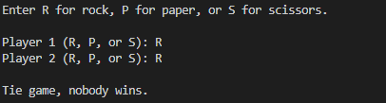

2.
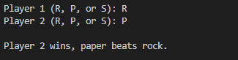

3.
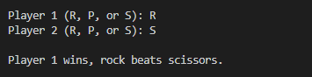

4.
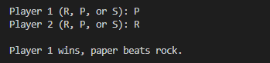

5.
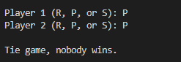

6.
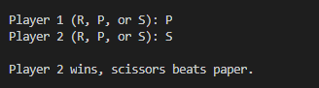

7.
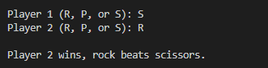

8.
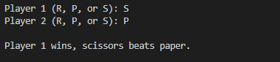

9.
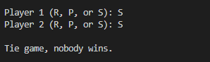

10.
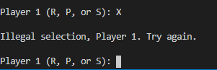

11.
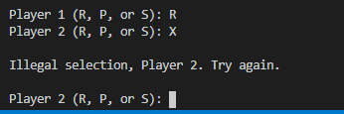

PROGRAM LISTING:
6) Copy and paste the code that YOU typed to make the program work. Your program should include a comment block at the top that shows the name of the program, date, version and your name.
/*
* RockPaperScissors-V1.0 - Determines the game winner from Rock-Paper-Scissors
* C++ version
* Name: Jay Gupta
* Date: 2/14/2020
* Inputs: player1 and player2 as (R)ock, (P)aper, or (S)cissors
* Output: the winner of the round
*/

#include <iostream>
using namespace std;

int main()
{
char player1, player2;
char playAgain = 'y';
cout << endl << "Welcome to Rock, Paper, Scissors!!!" << endl;
cout << "---------------------------------------------------" << endl;
cout << "The rules are simple: paper beats rock, rock beats scissors, and scissors beats paper." << endl;
cout << "If both players throw the same thing, its a tie." << endl;

cout << endl << "Enter R for rock, P for paper, or S for scissors." << endl << endl;
do {
do {
cout << "Player 1 (R, P, or S): ";
cin >> player1;
player1 = toupper(player1);
if (player1 != 'R' && player1 != 'S' && player1 != 'P') {
cout << endl << "Illegal selection, Player 1. Try again." << endl << endl;
}
} while (player1 != 'R' && player1 != 'S' && player1 != 'P');

do {
cout << "Player 2 (R, P, or S): ";
cin >> player2;
player2 = toupper(player2);
if (player2 != 'R' && player2 != 'S' && player2 != 'P') {
cout << endl << "Illegal selection, Player 2. Try again." << endl << endl;
}
} while (player2 != 'R' && player2 != 'S' && player2 != 'P');

if (player1 == player2) {
cout << endl << "Tie game, nobody wins." << endl;
} else if (player1 == 'P') {
if (player2 == 'R') {
cout << endl << "Player 1 wins, paper beats rock." << endl;
} else if (player2 == 'S') {
cout << endl << "Player 2 wins, scissors beats paper." << endl;
}
} else if (player1 == 'R') {
if (player2 == 'P') {
cout << endl << "Player 2 wins, paper beats rock." << endl;
} else if (player2 == 'S') {
cout << endl << "Player 1 wins, rock beats scissors." << endl;
}
} else { // player1 is scissors
if (player2 == 'R') {
cout << endl << "Player 2 wins, rock beats scissors." << endl;
} else if (player2 == 'P') {
cout << endl << "Player 1 wins, scissors beats paper." << endl;
}
}

cout << endl << "Do you want to play again? (Y)es or (any other key) for No: ";
cin >> playAgain;
playAgain = toupper(playAgain);
cout << endl; // blank line between games
} while (playAgain == 'Y');

cout << "Thanks for playing. See you later!" << endl << endl;

return 0;
}

